

BUDGET COMMITTEE

MEETING MINUTES
Friday, February 11, 2011
After the Town Deliberative Session at HMS

PRESENT: Proctor Wentworth, Brian Vass, Tracey McCormick

CALL TO ORDER: Chairman Tracey McCormick called the meeting to order at 9:10 PM at Hampstead Middle School.

Budget/Warrant Articles
Note the Committee only had to review the one Article that was changed during the Deliberative Session held earlier in evening that was related to finances. The committee read the changes, discussed it and then voted.

The changed Article is Art. 13 Town Operating Budget- The original amount of $5,187,445 was changed. An amendment to increase the budget by $30,000.00 making the bottom line at $5,217,445 was approved at The Town Deliberative Session.

According to a Warrant article passed in 2008 each vote needs to be tallied and recorded. During this meeting only three members were present. One member was not present during the Budget Committee meeting held for first votes on the Warrant Articles back in January.

The chart below shows all required data for the vote.

Article | On Motion by | 2nd | Abstained | Yes votes | No votes | Recommended  YES or NO and total vote
13 | Brian | Proctor | 0 | 2 | 1 | _2_ Yes _1_ NO

First meeting for New year -- Date: 4/14/11 Time: 7:00 pm Location: Selectman Office

ADJOURNMENT
- On a motion from Proctor, seconded by Brian, the meeting was adjourned at 9:16 pm.

For the Committee

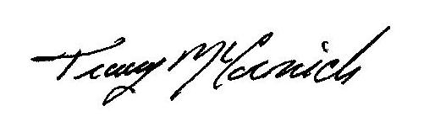
Chairman

